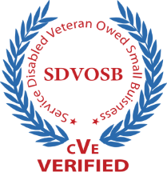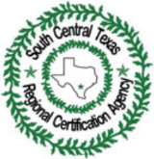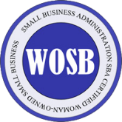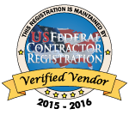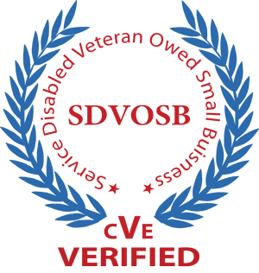

**www.robeckconsulting.com**

**Duns – 877270319/Cage – 7C0U3**

Our company is 100 % owned and operated by determined veterans accustomed to tackling tough problems and providing solutions. We are servant leaders, strategic thinkers and doers. Our strengths are derived by individual initiative, discipline and hard-won experience. We have impeccable credentials with strong qualities of mind and character.

541611 – Management Consulting Services

541612 – Human Resources Consulting Services

541618 – Consulting Services

541511 – Computer Programming Services

541512 – Computer System Design Services

541513 – Computer Facilities Management Services

518210 - Data Processing, Hosting and Related Services

611420 – Computer Training

611430 – Professional and Management Development Training

We provide Management and Business Consulting services with a wide range of expertise from high – level to entry level in support of your needs in fulfilling all your IT support, Project/Program Management and training needs using streamlined practices and our *Flat Organizational*  
 structure

**Capabilities**

*Robeck Consulting owners have consulted and worked in the*

*Corporate environment, Federal, State and Local governments*

*for over 25 years. Typical projects that we can help you with*

*are:*

* *Saas/Iaas/Cloud Computing Technology*
* *Program/Project Management*
* *Strategic IT Planning and Implementation*
* *Business Continuity/Disaster Recovery Planning*
* *Network/System Design/Implementation Services*
* *Custom Software/Web Development*

*Our Most Recent Customers:*

* *Argo Group International – Enterprise Software Development/Hardware Deployment*
* *Southwest Credit – Enterprise Consulting, Network/Systems IT Support, Software*
* *Excelsis Energy – Enterprise Consulting, Cloud Computing, Software Web Design*
* *Novus Energy Group – Enterprise Consulting, Cloud Computer, Infrastructure*

**Past**

**Performance**

**DIBE, ESBE, HABE, MBE, VBE, WBE**

**South Central Texas Regional Certification Agency (SCTRCA) – Certification # 215049190**

**Small Business Administration (SBA) Certified Woman-owned Small Business**

**Certifications**

**Company**

**Overview**

***Phone (210) 381 – 3025* | *Fax: (253) 679 - 5978***

[www.robeckconsultinggov.com](http://www.robeckconsultinggov.com/) | [info@robeckconsulting.com](mailto:info@robeckconsulting.com)

Robeck Consulting; L.L.C.



**www.robeckconsulting.com**

* Microsoft Partner Network – Partner ID 4530849
* American Info Systems (AIS) – American info Systems is a full service technology firm specializing in in strategic planning, execution and support of technology.
* True North – True North is a full service recruiting and executive search firm specializing in Accounting, Finance, Information Technology, Supply Chain and Business Optimization services.
* ITOPIA – ITOPIA provides end – to end cloud computing services including Platform as a Service (PaaS), Software as a Service (IaaS) and Software as a Service (SaaS)

Our Partners

We understand that your organization is a unique combination of culture, people and priorities which means your solutions need to be tailored to your specific needs and we will custom tailor a solution that is unique to you. Because we have a *flat organizational* structure, and use streamlined practices, we are able to accomplish the following:

* ***Flexibility*** – We understand the need for flexibility and make it easy for you to work with us
* ***Customer Focused*** – We use a *Laser* to focus on your mission and goals to ensure your success
* ***Technically and Professionally Capable* –** We use only the most qualified personnel who have a high level of competencies in their respective areas of expertise and professionalism to achieve success.

Why Robeck

Our Values

As a 100% veteran owned and service disabled veteran owned company, we pursue our core competencies with vigor, tenacity, sincerity and passion. We undertake the complexities surrounding typical projects with a deliberate energy, focusing on the objectives to deliver tangible results that will drive your success now and your *long term* success. Our values are driven by:

* **Servant Leadership** – We put your needs first and provide *constructive vision*, *perseverance* and *motivation*
* ***Integrity/Honesty*** *–*  We lead by example building trust and cohesion through positive communication, respectable behavior and fiscal responsibility
* ***Value*** – We provide you with measurable benefits that positively impact your bottom line

Our Mission

Our mission is to provide you with the highest quality of *service*, *products* and *value*. We accomplish this by seeing issues as opportunities and turning them into solutions that work for you. We will proactively work with you to solve problems, create solutions and provide you with professional augmentation for your corporate staff.

Using Robeck Consulting provides you with all the tools you need to take a competitive advantage while increasing productivity and reducing overall costs and providing value to your internal and external customers.

Robeck Consulting; L.L.C.